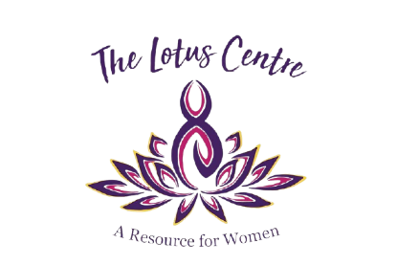
The Lotus Centre: A Resource for Women
Join our team of women empowering women
Diversity and Inclusion are key when providing services to women in our community. Would you like to join the volunteer board of directors?
We are seeking fresh new faces with skills in the following areas: accounting and financial skills, legal knowledge and application, BIPOC and 2SLGBTQIA+ knowledge, and fundraising skills.
Name
Phone
Email
* please use back of this page if more space is needed *
1. Tell us about yourself and your reason for applying?

2. Do you have any experience on a volunteer or non-profit governance board?
3. What is your current or most recent employment?

4. What is your educational history?

Thank you for interest in our Board of Directors.
We contact all applicants via email with a decision before our annual AGM.

